Recursion Models

AMDM Creating Explicit Models Name:

**Find the requested term of the sequence given the RECURSIVE or EXPLICIT definitions.**

1) Determine  , given that  and 

2) Determine  , given that  and 

3) Determine  , given that  and 

4) Determine  , given that  and 

**Find the requested term number of the sequence given the RECURSIVE or EXPLICIT definitions.**

5) Given that  and , determine which term of the sequence is 515.

6) Given that  and , determine which term of the sequence is 241.

**Find the RECURSIVE & EXPLICIT definitions and then find the requested term**

7) 3 , 5 , 7 , 9 , 11 , .... Find a42=

Recursive:

Explicit:

8) 5 , 8 , 11 , 14 , .... Find a33=

Recursive:

Explicit:

9) 4 , 12 , 36 , 108 , .... Find a21=

Recursive:

Explicit:

**Answer the following about the pattern sequences.**

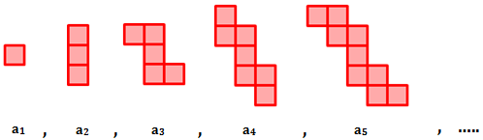10) Jessie started creating the following pattern using red square blocks. How many red squares will she need for the 12th step

of the sequence?

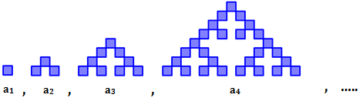11) Ethan started creating the following pattern using blue square blocks. How many blue squares will she need for the 8th step

of the sequence?

12) Ashley started drawing several iterations of a binary tree. In each iterative step, the number of new leaves is doubled. How many new leaves will there be on the 9th step of the sequence?

